

**Monetary policy: navigating rough waters**

Speech given by

Martin Weale, External Member of the Monetary Policy Committee

At the Hart Brown 8th Annual Economic Forum, School of Management, University of Surrey, Guildford

21 June 2012

I would like to thank Robert Gilhooly and Tomasz Wieladek for research assistance. I am also grateful for helpful comments from other colleagues. The views expressed are my own and do not necessarily reflect those of the Bank of England or other members of the Monetary Policy

All speeches are available online at [www.bankofengland.co.uk/publications/Pages/speeches/default.aspx](http://www.bankofengland.co.uk/publications/Pages/speeches/default.aspx)

Thank you very much for inviting me here to talk to you this evening. For the economy the recent ride has been choppy, to say the least, and I fear that further rough waters may lie ahead. Over the last few weeks many of us have been looking nervously at developments in the euro area. In a globalised economy with free movement of capital even fog in the Channel would not be enough to isolate the continent and to protect us from the continuing uncertainty there. In this context, the Bank’s Governor (King, 2012) announced last week new measures to support the UK economy. The results of the Greek elections may have prevented an immediate acute crisis. But I am still not sure how the peripheral countries of the euro area are going to manage their debts.

The enveloping crisis is probably an important factor why economic growth has been so weak recently. The most recent GDP figures, for 2012Q1 show a growth rate over the last year in a region to which we gave a probability of less than ten per cent1 when we produced the first MPC forecast I contributed to, just under two years ago.

# Chart 1: GDP forecast vs outturn Chart 2: Inflation forecast vs outturn

Percentage increases in output on a year earlier

7



6

5

4

3

2

1

0

-1

-2

-3

-4

-5

-6

-7

06 07 08 09 10 11 12 13

Percentage increase in prices on a year earlier

6



5

4

3

2

1

0

-1

-2

06 07 08 09 10 11 12 13

Sources: Bank of England and ONS (a) The diamond shows an average of the April and May CPI figures

Sources: Bank of England and ONS

Inflation has surprised us in the other direction. Much of the rise last year, together with the fall seen at the start of this year was a consequence of the VAT increase to twenty per cent which came at the start of 2011. This had, however, already been announced at the time when the forecast was prepared in August 2010.

So, while the increase in the VAT rate contributed to the inflation rate, it cannot be used to explain why the inflation rate was well above the centre of our range. It should be noted that the outcome for much of the

1 The fan charts are symmetric; hence, for GDP growth, the 10 per cent figure quoted refers to the white areas both above and below the outermost band.

time has been broadly within the outermost shaded area suggesting that, over this period, we gave a roughly twenty per cent chance to something like this happening or worse.

Let me comment first on inflation. Of course we can identify particular factors that have driven the increase in the consumer price index. As we know, the VAT rate was increased from 17 ½ % to 20 % adding probably just over 1 per cent to the Consumer Price Index (CPI). And oil and other fuel prices have been buoyant. Chart 3 shows the contributions of various factors to inflation up to March of this year; late last year VAT and fuel prices added over two percentage points to the inflation rate.

# Chart 3: Contributions to CPI inflation(a)

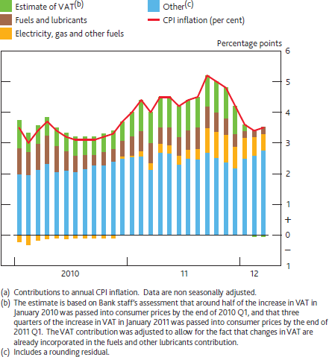

Over the period since I joined the MPC, the average inflation rate has been just under 4% per annum. Had fuel prices risen in line with the rest of the CPI and had VAT not gone up, then the average increase in the CPI index since I joined the MPC would have been, at an annual rate, 2.9% rather than just below 4%, still above target but less of an embarrassment.

But, while I am comfortable leaving out the effects of VAT, it can reasonably be asked whether picking and choosing beyond this gets us very far. The target we have been set is the Consumer Price Index, not the

Consumer Price Index excluding this or that. Britain is often regarded as a nation of gardeners. So it is bad luck that, over the same period the price of tools and equipment for house and garden rose by 11 per cent at an annual rate. On the other hand, had the MPC been able to persuade the public that they should focus their consumption on audio-visual, photographic and data processing equipment the price index would have fallen by 9 per cent at an annual rate. At least this would be true provided that people sat in the cold and did not watch television. The price of electricity has, after all, risen along with that of other domestic fuels.

Often the argument is made that, because wages and many prices are sticky, movements in the price level arising from factors such as changes to the oil price, or to import prices, should be accommodated. With sticky wages and prices, an attempt to deliver the target despite such movements would be costly. But too much can be made of this. A careful study led by one of my predecessors (Nickell and Quintini, 2003) found that there was much less rigidity in hourly wages than was often assumed, and a more recent examination using data from the Labour Force Survey confirmed this, despite the introduction of the minimum wage in 1999. A more refined argument for accommodation of short-term movements, and one to which I do subscribe, is that policy decisions are thought to have their peak effect on inflation after two years or so. An attempt to keep inflation close to target in the short term in the face of large shocks would be destabilising and the effects of oil prices and similar disturbances should be accommodated only insofar as they come through before monetary policy can reasonably have much effect. And, to the extent that they can be anticipated, far enough ahead, they should not be accommodated at all. Accommodation creates the risk that expectations of higher inflation will become built in to people’s behaviour with the consequence that delivering the inflation target will become harder rather than easier. This applies as much to any accommodation of inflation as a way of easing debt burdens as it does to accommodating the effects of

long-term movements in relative prices.

Fortunately the last few months have seen a very welcome easing of raw material prices, as chart 4 shows – for example the oil price has now fallen below $100 per barrel and prices of other fuels have come down.

This raises the prospect of inflation later this year being lower than had seemed likely even a month ago. Also, recent data are starting to suggest that wage pressures are weak; it does not seem that recent inflation has been reflected in pay bargaining. The May inflation figures, announced earlier this week, show, with inflation at 2.8 per cent, that the benefits of lower oil prices are now influencing the headline numbers. This reduces the risk of expectations of high inflation becoming built in to people’s behaviour.

**Chart 4: Commodity Prices(a)**

Indices, 2008 =100

160

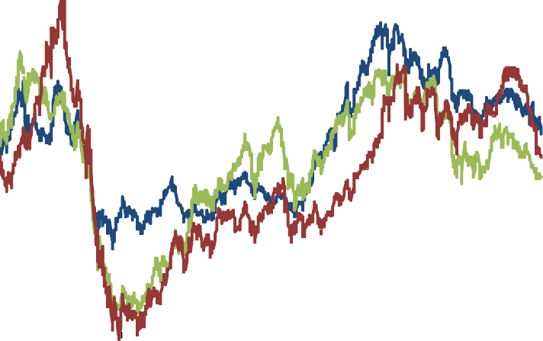

**Agriculture and livestock**

**Industrial metals**

**Brent Crude**

140

120

100

80

60

40

2008 2009 2010 2011 2012

(a) The agriculture and livestock and industrial metals series are calculated using S&P (dollar) commodity price indices.

Sources: Standard & Poor's and Thomson Reuters Datastream

A further factor may bear down on inflation next year although at present there is no certainty about this. At the time of the financial crisis in 2008 it was suggested that policy might have been rather different if housing had been included in the Consumer Price Index. I think the view was that because house prices had risen fairly rapidly in the period before the crisis, the use of an index which included housing would have led the bank to adopting a tighter policy stance, which might have resulted in a smaller eventual crisis.

The Office for National Statistics has worked on how housing might be included in the Consumer Price Index for a number of years. The ONS work was overseen by the Consumer Prices Advisory Committee of which I am one of sixteen members and its proposals were put out to consultation a couple of weeks ago (Office for National Statistics, 2012). For very good reasons the recommended new measure of the Consumer Price Index (CPIH) does not differ greatly from the existing indicator. It will not be, and should not be expected to be a means by which the MPC takes account of the effects of spending out of capital gains on houses on future inflation. But the proposed index has recently2 shown an inflation rate of 0.3 to 0.5 per cent per annum less than that indicated by the CPI. I have no basis for predicting whether that will persist: in earlier periods CPIH has shown faster inflation than has CPI.

The ONS is proposing to implement the new index early next year, but only, of course, in the light of the consultation and only if the independent Statistics Authority accepts the proposal. If the new index is

2 To December 2011.

introduced, the Chancellor will need to decide whether to change the inflation target set for the MPC. Ahead of these decisions, this is an additional source of uncertainty that the MPC cannot do much about.

When the weak GDP figures for 2012Q1 were published, news reports suggested a sense of disbelief from City economists. Business surveys had shown a rather more buoyant picture and the immediate response was that there must therefore be something wrong with the GDP data. But, assertions that a range of business surveys are inherently much better than early estimates of GDP should be treated with caution; the main conclusion from statistical analysis is that neither is a very good guide to the final position3. So, while business surveys are useful as indicators of the current state of the economy, because of the inevitable lag in the production of official data, it would be quite wrong to infer that any divergence between them and early official estimates will necessarily be resolved, by the revision process, in favour of the former. I am confident that the GDP figures will be revised again but would not like to say whether this will be up or down. In any case the most recent business surveys are less at odds with GDP. The buoyant picture that they gave in the first quarter of the year, both at home and abroad has now faded. As chart 5 shows, the issue is not so much that they are signalling a sharp contraction as that they are consistent with no perceptible economic growth in the recent past and very near future - hardly a satisfactory state of affairs.

# Chart 5: Composite CIPS/Markit PMI indices and GDP growth (a)

Indices 80



**Expectations**

**Output**

75

70

65

60

55

50

45

40

35

2005 2006 2007 2008 2009 2010 2011 2012

(a) The composite CIPS/Markit PMI output (expectations) index weights together the manufacturing output (new orders), services business activity (business expectations) and construction total industry activity (future activity) indices using shares in nominal value added. Shaded areas show the composite CIPS/Markit PMI indices consistent with GDP growth between 0% and 0.5% QoQ, based on survey indices scaled to match the mean and variance of GDP growth since 1997.

Sources: CIPS/Markit and Bank calculations

The biggest counterpart of our economic weakness since 2008Q1 has been poor productivity performance and that was particularly disappointing at the start of the year. Output fell while employment rose suggesting

3 See Ashley *et al.* (2005). This shows that survey data have only a poor ability to explain final GDP figures.

that output per worker declined. The causes of this weak productivity growth are not known. Indeed the debate about whether productivity movements are largely exogenous drivers of economic cycles, as argued by Kydland and Prescott (1983) or are the outcome of movements in demand, as argued recently

Miles (2012) and also at greater length by Martin and Rowthorn (2012) is one which will probably never be resolved. The fact that standard economic models assume that productivity is largely exogenous should not, of course, close our minds to the possibility that the assumption may be wrong.

There is as yet no clear evidence that innovative activity, a probable driver of productivity, has slowed. Indeed, the one type of investment which has held up is expenditure on research and development, at least up to 2010, the last year for which there are data. Nor is the weak rate of business investment so weak as to account directly for the productivity puzzle, although there may be a connection between weak investment and a failure to implement innovation. But the fact that no satisfactory supply side explanation of productivity performance has been found does not automatically imply that the explanation must lie on the demand side, and still less that a sharp improvement in demand would result in above-trend growth of labour productivity.

It has been suggested that the distinction between fixed and variable labour explains weak productivity. When demand fails to grow businesses shed variable labour while they retain their fixed labour in the hope of better times ahead. There is something to this. The Labour Force Survey can be used to calculate the percentage change in employment by type of occupation both since the start of the crisis in 2008Q1 and since the low point for employment in 2010Q1. The brunt of the adjustment has been borne by the

non-professional occupations. But employment in the categories managers, professionals and associate professionals has risen by 2.4% since the start of the crisis, while that of other occupations has fallen by 5.6%. Most of the rise in the former category has taken place since 2010Q1 while employment in the latter category has fallen 0.3 per cent since 2010Q1. Some of these movements may be the result of the occupational equivalent of grade inflation. But it nevertheless seems odd that the response to weak demand should be to take on extra managers, professionals and associate professionals.

Historical parallels, such as they are, argue against a clear and direct link between stagnant GDP and stagnant productivity. Thus, from 1990Q3 to 1992Q3 GDP fell by nearly one per cent while productivity increased by over six per cent. In the earlier recessions of the 1970s and 1980s productivity turned up ahead of GDP. It cannot be said that these observations settle the matter, beyond doubt, but nor could any statistical analysis be expected to. So I do not see that it is intellectually possible to take an entrenched view that our recent productivity performance either is or is not demand driven. All it is possible to do is to form a view as to the balance of probabilities associated with the different explanations.

From the MPC’s point of view the question is not whether the recent weakness in productivity is a consequence of weak demand or indicative of supply problems. Rather the question we need to address is whether a sharp increase in demand would prevent inflation from falling back to target or not. I am very

doubtful that the productivity ground we have lost over the last four years would be fully, or even largely, recouped if there were a sharp increase in demand in the near term. And I am not sure whether many of those who assert that the productivity problem is a demand problem believe this. But it is rather more likely that productivity would start to grow at something like its trend rate if demand were more buoyant and the easing of inflationary pressures reduces the risks associated with this.

As chart 5 above showed, far from improving, immediate prospects for the economy have worsened. At a time when the improving inflation outlook is creating room to see whether extra demand would lead to faster productivity growth without running undue inflationary risks, actual underlying demand does not seem to be strengthening. Data for April suggest that the international environment has become considerably worse; exports to both the United States and Germany fell sharply. Export data are volatile but, nevertheless, this is hardly good news. Uncertainty is probably also deterring spending at home

A particular consequence of the crisis has been higher costs of bank funding at home, adding to the squeeze on domestic investment. Chart 6 shows the typical credit default swap premium faced by UK banks, an influence on the excess of their funding costs over Bank Rate. We can see that this rose sharply late last year and remains very elevated; lenders to UK banks know that these are exposed to French and German banks. And the latter have lent heavily to banks and other borrowers in the peripheral part of the euro area. On top of the general atmosphere of uncertainty it has created, the crisis has made banks more risky than they were, pushing up the cost of bank credit to businesses and households wanting to borrow.

My visits to businesses give a clear impression of the large gap between the Bank Rate which we set and the effective or “shadow” cost of credit to business. I hear about discounts of two to three per cent for customers who pay immediately rather than at ninety days, suggesting an underlying shadow interest rate of ten per cent per annum or more. Our past asset purchases have probably provided some support to the economy, even if it is not clear how much4. But they have not had, and could not have been expected to have, the effect of bringing the rates set by banks, or the effective rates faced by businesses which do not have easy access to equity or other types of non-bank capital, much closer to Bank Rate5.

4 Thus Pesaran and Smith (2012) suggest the impact has been appreciably weaker than the Bank’s central estimate.

5 Bank of England (2011, p. 12) provides an account of the MPC’s views on the channels through which asset purchases operate.

# Chart 6: Bank funding costs are elevated

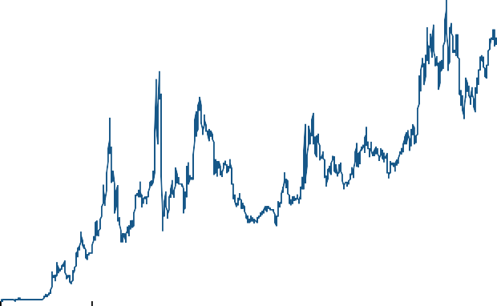

Percen tage points

3.5

3.0

Five-year CDS premia(a)

2.5

2.0

1.5

1.0

0.5

0.0

2007

2008

2009

2010

2011

2012

(a) The data show a simple average of the five-year CDS premia of Barclays, HSBC, Lloyds Banking Group, Nationwide, Royal Bank of Scotland and Santander UK.

Sources: Bank of England, JPMorgan Chase & Co., Markit Group Limited and Bank calculations.

It seems highly likely, although of course we cannot be certain, that high interest rates and, in all probability, credit rationing, are factors depressing the economy. The Federation of Small Businesses reported a slight increase in the proportion of credit applications by their members being turned down in the current quarter. But the series is not of long standing making a full statistical interpretation impractical.

If banks could lend more, and do it more cheaply, that could help deliver a more normal pattern of demand growth. The Committee was notified at its June meeting about the discussions under way between the Treasury and the Bank about how best to ease banks’ funding costs and how to enhance their ability to lend. While I shared the view that further monetary stimulus could be applied to the economy without putting the inflation target at risk, I wanted to wait for the outcome of these discussions before I felt able to come to a view on the appropriate stimulus.

# Chart 7: Forward 3 month LIBOR before and after the ECTR announcement

Futures curve on June 13th Futures curve on June 15th

1.6



1.4

1.2

1

0.8

0.6

0.4

Source: Bloomberg

Things have moved on since then. At Mansion House the Governor (King, 2012) spelled out more details of the plans, indicating that the Extended Collateral Term Repo (ECTR) will be used to provide extra liquidity to banks. This should make banks more willing to lend. As shown in chart 7, the 3 month LIBOR future curve, a second influence on bank funding costs, declined by between 25-30 basis points following the ECTR announcement; this may lead to some easing of retail lending rates later in the year. The Committee will also need to take account of the Funding for Lending Scheme, a further means of reducing funding costs, as this is developed. The scheme will provide funding to banks of a type similar to that which they might obtain by selling secured bonds, but at a rate more favourable than the market would charge and with added benefits if they expand their lending.

Before the crisis it was generally assumed that setting monetary policy meant setting the price of money – varying the interest rate. Since 2008 we have seen that, for monetary policy to be effective in a wide range of circumstances, its tool-box needs to contain more than just a single spanner. The Chancellor recognised this when he spoke at Mansion House about “monetary policy in all its forms”. I suspect that, pound for pound, the new interventions will do more to support the economy than would deploying the same sums on further asset purchases. At the same time we have to recognise that the distinction between monetary policy, fiscal policy, regulatory policy and macro-prudential policy is no longer clear-cut. Both the ECTR and Funding for Lending affect the balance of risks associated with banking.

For the time being the ECTR and Funding for Lending are part of the back-drop for the MPC’s regular decision-making process. The ECTR, although a contingent liquidity facility, is part of the permanent Sterling Monetary Framework, and is designed “to respond to actual or prospective market-wide stress of an exceptional nature”. The Bank has announced that the ECTR auctions will run “at least once a month until further notice”. If the Bank were conducting reserves averaging under its normal framework, then the extra cash injection involved by the ECTR would ordinarily be offset by other routine operations. Given the current suspension of reserves averaging, as a result of quantitative easing, there will be a net injection of extra cash via the ECTR auctions, which although temporary and short-term in nature, is of course relevant to the MPC; indeed the anticipation of this can already be seen in the effects on forward LIBOR discussed above.

Should there be a need for long-term use of these or similar schemes, then, no doubt, frameworks will evolve, which recognise the cross-cutting nature of such instruments while at the same time ensuring that each policy-making body can discharge its responsibilities effectively. Otherwise policy-making will lose its independence. But any refining of current arrangements should obviously take second place to the task of ensuring that adequate support can be provided to the economy as it is needed, and in particular that, in the event of the situation deteriorating in the euro area, the UK economy can be protected as much as is possible6.

The waters through which the economy sails are rough; we remain very exposed to the effects of international disturbances. The Bank and Treasury have, however, taken important steps to provide extra monetary support for our financial system and thus for the economy as a whole. The easing of inflationary pressures means that there is much less risk of above-target inflation becoming entrenched than had seemed the case only a few months ago. This in turn means that there is appreciably more room for further monetary stimulus. It would be too much to expect that all of this will deliver a calm sea and a prosperous voyage; there is only so much that can be expected of monetary policy and that is especially true in the current international environment of high uncertainty. But it will certainly help.

After these observations on the current situation I would like to end by drawing a parallel between our

longer-term prospects and the period of growth the UK economy enjoyed in the years after the Second World War. Matthews (1968) argued that this was in large part a consequence of buoyant investment demand as businesses took advantage of the opportunities which had built up, but not been exploited, in the 1930’s and during the War. That period was associated with accelerated productivity growth. In much the same way, I think it quite likely that, when more stable economic conditions have returned, businesses may be able to take advantage of a backlog of investment and innovation opportunities, leading to a virtuous circle of relatively high investment and rapid productivity growth. But it would be rash indeed to suggest any

time-scale for this process and I would certainly not want to build it in to our short and medium term forecasts.

6 Posen (2012) made a similar point.

**References**

**Ashley, J, Driver, R, Hayes,S and Jeffrey, C (2005),** “Dealing with data uncertainty”, *Bank of England Quarterly Bulletin*, Vol. 45 (1), pp 23-30. <http://www.bankofengland.co.uk/publications/Documents/quarterlybulletin/qb050101.pdf>

**Bank of England (2011).** *Inflation Report* November 2011. <http://www.bankofengland.co.uk/publications/Pages/inflationreport/ir1104.aspx>

**King, M (2012),** Speech Given by Sir Mervyn King. 14th June 2012. <http://www.bankofengland.co.uk/publications/Pages/speeches/2012/587.aspx>

**Kydland, F E and Prescott, E C (1983),** “Time to Build and Aggregate Fluctuations”. *Econometrica*. Vol 50, pp. 1345-1370.

**Martin, R and Rowthorn, R (2012),** Is the British Economy Supply-constrained II? A Renewed Critique of Productivity Pessimism. Centre for Business Research. University of Cambridge.

**Matthews, R C O (1968),** “Why has Britain had Full Employment since the War?”. *Economic Journal*. Vol 96, pp 555-569.

**Miles, D (2012),** Monetary Policy and the Damaged Economy. <http://www.bankofengland.co.uk/publications/Pages/speeches/2012/576.aspx>

**Nickell, S and Quintini, G (2003),** “Nominal Rigidity and the Rate of Inflation”. *Economic Journal*. Vol 113, pp 762-781.

**Office for National Statistics (2012),** Consultation on the Recommended Method of Reflecting Owner Occupiers’ Housing Costs in a New Additional measure of Consumer Price Inflation, and the Strategy for Consumer Price Statistics.

<http://www.ons.gov.uk/ons/about-ons/consultations/open-consultations/owner-occupiers-housing-> costs/index.html

**Pesaran, M H and Smith, R P (2012),** “Counterfactual Analysis in Macroeconometrics. An Empirical Investigation in the Effects of Quantitative Easing”. Unpublished, <http://www.econ.cam.ac.uk/faculty/pesaran/wp.htm>

**Posen, A.**, (2012), “Making the Most of Doing More,” speech to the Barclays Short-Term Rates Seminar, London, 11th June.

<http://www.bankofengland.co.uk/publications/Pages/speeches/2012/585.aspx>